TRAVEL REQUEST
START BY SELECTING “START A REQUEST” AT THE TOP OF YOUR UF GO HOME SCREEN.
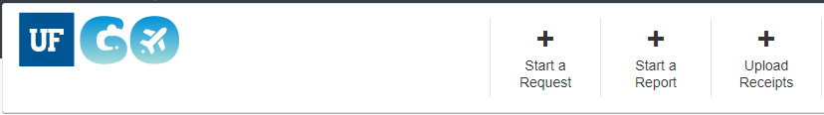
NEXT SELECT THE TYPE OF TRAVEL REQUEST YOU ARE REQUESTING
- NOTE: YOU SHOULD ALWAYS BE SELECTING ONE OF THE UFLOR REQUEST.
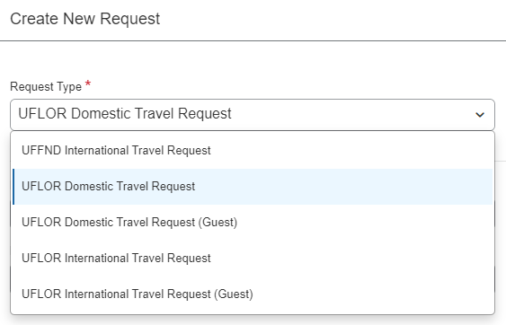
NAMING FORMAT
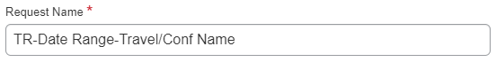
NAMING EXAMPLE
COMPLETE ALL REQUIRED FIELDS INDICATED BELOW AS IT PERTAINS TO YOUR TRAVEL:
- TRIP TYPE – drop down
- TRAVELER TYPE – drop down
- BENEFIT TO GRANT OR UNIVERSITY – fill in and be specific
- BUSINESS TRAVEL START DATE – fill in
- BUSINESS TRAVEL END DATE – fill in
- FINAL DESTINATION LOCATION – start typing and choose the auto-fill
- BUSINESS PURPOSE – drop down
- WILL THIS TRIP INCLUDE PERSONAL TRAVEL?
  - If yes, you are required to indicate what dates are personal travel.
- ARE YOU TAKING UF PROPERTY? – drop down
- IS THIS TRIP PARTIALLY OR FULLY PAID BY A THIRD PARTY? – drop down
BUDGET INFORMATION:
- IF YOU ARE UNCLEAR ON HOW TO PROCEED WITH THIS ENTRY, PLEASE EMAIL YOUR FINANCE TEAM AND THEY WILL PROVIDE YOU CLARIFICATION.
- STUDENTS: If you do not know your funding chartfield, ask your PI for the name/project and put it in the comments. E-mail finance@mse.ufl.edu and they can fill it in before submission.
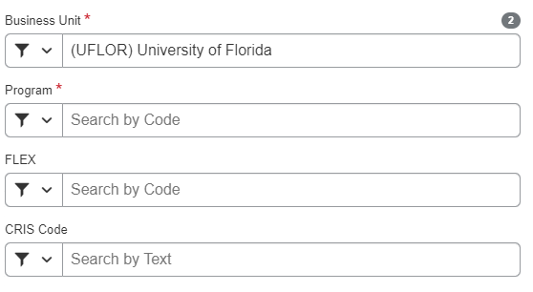
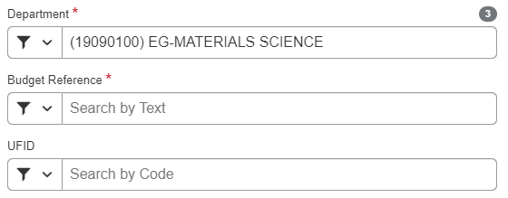
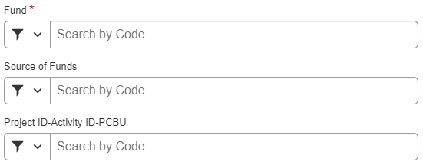
COMMENTS SECTION:
FACULTY ARE REQUIRED TO INPUT THEIR MISSED CLASS HOURS HERE AND INDICATE WHAT PROVISIONS ARE BEING MADE FOR TEACHING THE COURSE IN YOUR ABSENCE.
ONCE ALL OF THE ABOVE HAS BEEN COMPLETED CLICK CREATE REQUEST.
ONCE CREATED YOU WILL ADD YOUR EXPECTED EXPENSE:
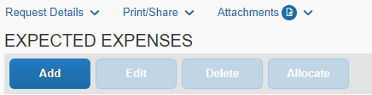
EACH EXPENSE WILL BE ONE LINE ITEM. NOTE YOUR TRAVEL REPORT IS AN ESTIMATED AMOUNT OF YOUR EXPENSES AND DOES NOT NEED TO BE EXACT.
EXAMPLE OF EXPENSES:
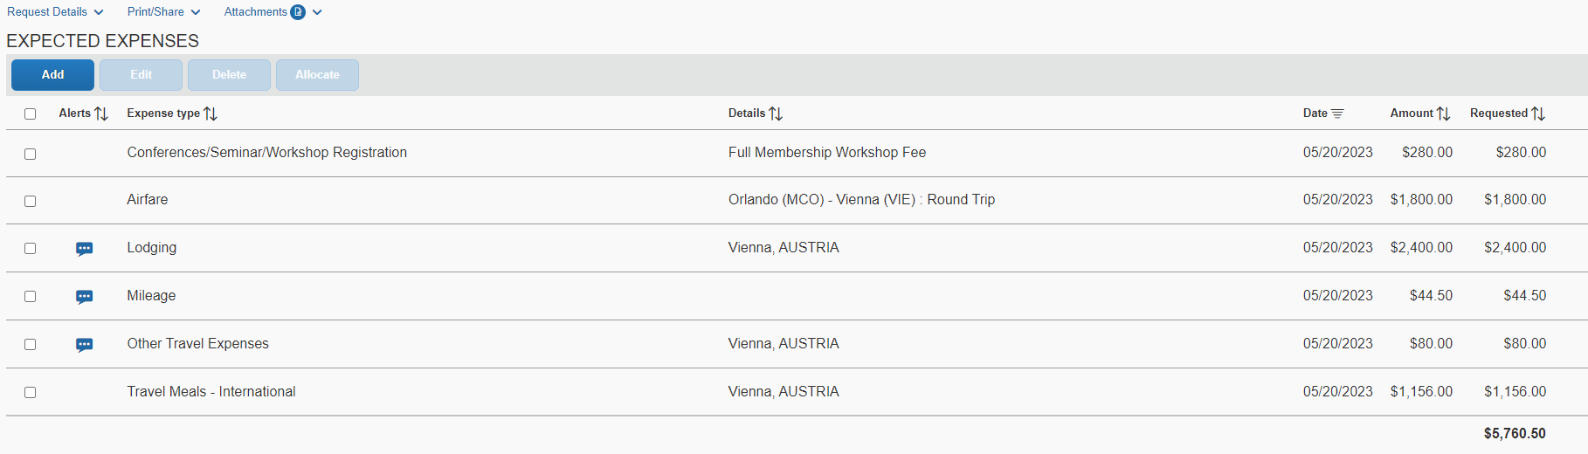
CLEAR YOUR ALERTS:
BE SURE TO CLEAR ANY ALERTS ESPECIALLY RED ALERTS, TO CLEAR THESE YOU WILL CLICK ALERTS TO OPEN THE DROP DOWN AND READ EACH ALERT TO RESOLVE.
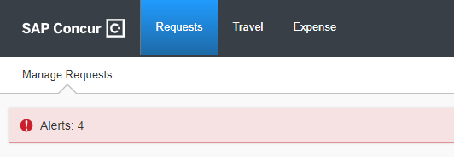

These alerts will remain as FYIs – that is fine.
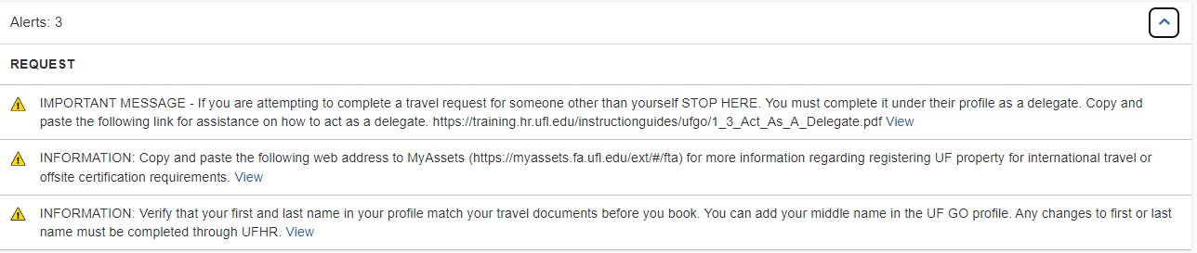

IF YOU HAVE ANY QUESTIONS OF CONCERNS, PLEASE DO NOT HESITATE TO EMAIL YOUR FRIENDLY FINANCE STAFF. WE WILL BE HAPPY TO REVIEW YOUR TR BEFORE SUBMISSION.

